Testimonials for Quirky Bird Theatre
That Face by Polly Stenham
Schools Tour 2017-18

From the teachers:
“Just finished a fantastic workshop and performance evening with Quirky Bird Theatre and their touring production of Polly Stenham’s ‘That Face’. For anyone studying this for component 3, cant’ recommend them enough; really insightful, engaging and super intense!”
“todays lesson showed a great improvement already with performance choices and justifications from the students. Thank you Quirky Bird Theatre!”

From the students:
“such a rollercoaster of emotions! I feel exhausted and completely drained. Excellent insight into each of the characters and great to finally be seeing the performance”
“very clever take on the play. Brilliant to watch”
“ the performances were honest and completely genuine. Amazing work, you’ve opened my eyes”
“I thought it was very helpful, I enjoyed the workshop and felt the whole thing was really beneficial…characters portrayed really well”
“Really useful to watch and join in with. I genuinely enjoyed all the tasks and the opportunity to work with you all. Super talented!”
“I found the workshop really useful as it helped explore the characters in depth and to discover different interpretations of the characters”
“The workshop was a different way of getting to know the characters and their complexity – it was very interesting”
“The workshop was very helpful in revising my ideas of the characters and the dynamics between them. I enjoyed the depth we went into. I liked the participation of the actors gave a sense of what it should be”
“Eye-opening…helpful…speechless!” “Incredible, really well done”
“refreshing, enlightening, encouraging” “Helpful, informative, wonderful”
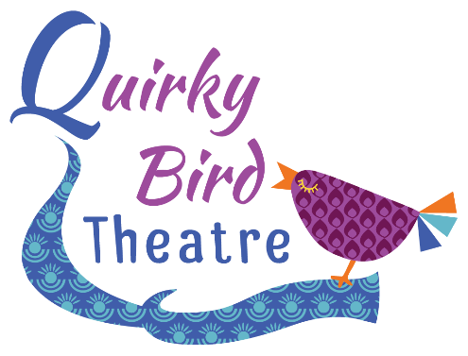
“confidence building, awe-inspiring”

DNA by Dennis Kelly
Schools Tour 2017-18

From the teachers:
I'd like to say a huge thank you to the Director and Cast members at Quirky Birds. We hired them in to perform DNA and paid for the extra workshop afterwards and the excitement from my students about the play and the characters is still there days later! The cast members were so open and friendly with my students and put them at ease straight away to the point where students who are usually too nervous to perform went on stage and performed in front of the whole hall with confidence and conviction I had never seen before.

Thank you for helping my students understand the text and bring it to life! I will be asking for them to come back again next year.

From the students:
“Amazing acting, created by some talented teenagers.”

“I found it very though-provoking. The physical theatre aspects were effective and made the monologues interesting and easy to watch”

“The staging was wonderful, it gave such a sense of the location but allowed the actors to full demonstrate their characters desolation”

“Oh wow. Leah. She was incredible. Magnetic in her portrayal.”

“Loved the focus on how silence tells a story, the way the relationships and the subtext was told through silences was exciting”

“They were so professional!”

