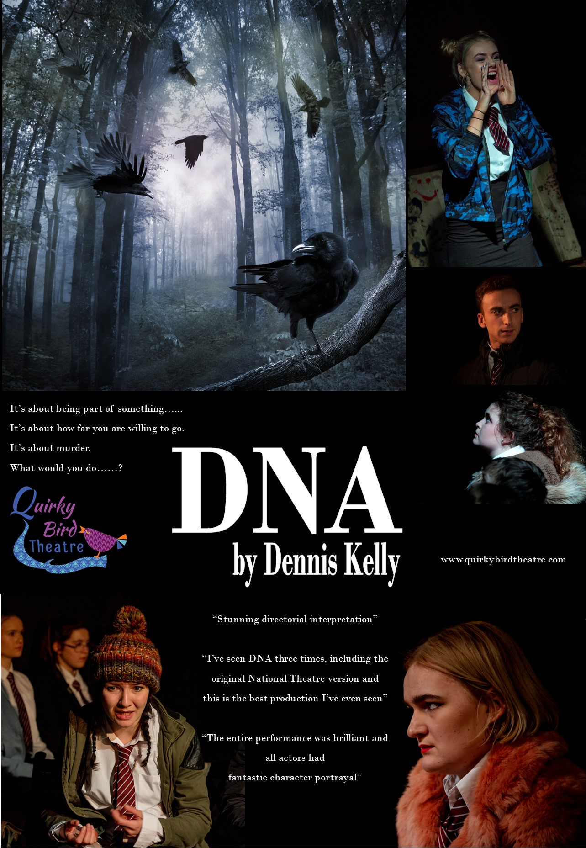

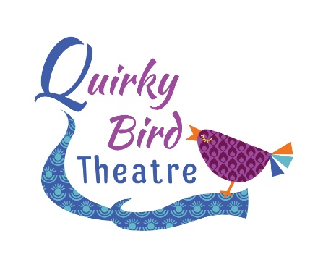

QUIRKY BIRD THEATRE
SCHOOLS TOUR
INFORMATION & PRICES

Thank you for interest in our schools tour of DNA by Dennis Kelly. This production has been touring schools since September 2017 and received fantastic student response and feedback.
From the teachers:
“I’ve seen DNA three times including the original National Theatre version and this is the best production I’ve seen”
“I'd like to say a huge thank you to the Director and Cast members at Quirky Bird Theatre. We hired them in to perform DNA and paid for the extra workshop afterwards and the excitement from my students about the play and the characters is still there days later! The cast members were so open and friendly with my students and put them at ease straight away to the point where students who are usually too nervous to perform went on stage and performed in front of the whole hall with confidence and conviction I had never seen before.”

“Thank you for helping my students understand the text and bring it to life! I will be asking for them to come back again next year.”

"stunning...superb directorial interpretation!"
"thank you so much for making DNA available as a live streamed event...they thoroughly enjoyed the performance and although you couldn't hear, they all applauded enthusiastically at the end"
"I can honestly say it was an outstanding experience. The quality of the performance was great, the pupils gained so much...it has put them in a great position to start their C3 preparation"

From the students:
“I found it very thought-provoking. The physical theatre aspects were effective and made the monologues interesting and easy to watch”

“The staging was wonderful, it gave such a sense of the location but allowed the actors to full demonstrate their characters desolation”

“Oh wow. Leah. She was incredible. Magnetic in her portrayal.”

“Loved the focus on how silence tells a story, the way the relationships and the subtext was told through silences was exciting”

Performances available at 10am & 3pm. Evening performances can be negotiated. Some flexibility is possible.

PLEASE NOTE THAT YOU ARE NOT ABLE TO INVITE OTHER SCHOOLS, EVEN THOSE WITHIN YOUR TRUST. ANY ACCESS TO THIS PERFORMANCE MUST BE ARRANGED AND PAID FOR THROUGH QUIRKY BIRD THEATRE IN LINE WITH OUR LICENCING AGREEMENT WITH CASAROTTO ON BEHALF OF DENNIS KELLY. FOR TRUST SCHOOLS PLEASE REFER TO HOST OPTIONS BELOW.

The schools package now offers the performance followed by 45-minute discussion & exploring the characters, themes and creative process. You will also receive an entended digital Q&A with director Anna Friend.

All cast members will be involved with the post-performance session where the students have the opportunity to interact with the company about decisions that were made during the rehearsal process and discuss and develop their own stage interpretation. This is led by members of the company. Teaching staff are required to be present throughout the session.
Fees for the Single School Package are as follows;
Performance and post show session (up to 120 students) £950 total price
Deposit required to secure your booking £300
Invoices will be sent out after confirmation has been received and a non-refundable deposit of £300 is needed to secure your booking. The balance of £650 is due 30 days before your performance.

Could you be a HOST??

If you have a large performance space that can accommodate 120+ audience members you can host other schools and pay a reduced fee for the performance. As a host school we will sell tickets to other schools to the performance at your venue
Take a look at the HOST school information below!

If you have a large performance space that can accommodate 120+ audience members that you may be able to have us for a reduced cost of just £300!!!

As a host school we will sell tickets to other schools to the performance at your venue which could mean you end up paying only £300.
Example: You have a theatre that seats 120 audience members. You have 40 students that would like to see the performance to enhance their exam preparation. You are able to sell the other 80 seats to interested schools, via Quirky Bird.
If there is a deficit left over once the seats have been sold (for example, you are only able to sell a smaller proportion of tickets), you are liable to make up the cost to a capped value of £650 (minus your £300 previously paid), but this would also be substantially less than you would pay should we visit your school as a single visit.
This package enables more students to access these productions and creates a vibrant and exciting theatre experience for everyone who takes part. All our 2022 venues have enjoyed fantastic atmosphere’s and exciting Q&A’s.
Both the school and Quirky Bird will advertise this event to maximise uptake.
All tickets are booked and paid for through Quirky Bird Theatre in line with the terms and conditions of our licence agreement with Casarotto. You will only need to secure 80 tickets from other schools to ensure your booking costs just £300.
All cast members will be involved with the post-performance session and normally there is an opportunity to interact with the cast following the Q&A for more specific questions.
Fees for the package are as followed;
Non-refundable Deposit required £300 required to secure booking
Host School Package £1250 sales threshold
Additional Resources Available
Creative Resource Pack: £65
- 14 Character Cards detailing context, performer decisions, key relationships and directorial vision,
- How to...Director and Designer Cards from Quirky Bird Theatre's Anna Friend
- Staging Breakdown and suggestions
- DNA - The Boardgame - Great Revision Tool!

Edexcel Support Pack £45
- Performance Skills breakdown,
- Tip Tops from Kirsten Lane for Exam Success,
- Example exam style answers for 9, 12 and 14 Marker
- PLUS..Access to over 4 Hours of filmed resources including exam workshop and Q&A resources with cast and Director, breaking down the written exam and helping students to really discover and analyse this fabulous play!
​
Full Digital Performance £50
Only available as part of your live performance booking.
Cancellation Policy
NOTE Quirky Bird Theatre is a unfunded, sole trader led arts company. In the wake of covid, we have had to develop an extremely robust cancellation policy to safeguard the future of our company, this tour and the employment of our young actors. Please do not request a full refund as this is not possible. Our terms and conditions are clearly detailed below. Many thanks.

- All deposits are non-refundable.
- In the unlikely event of a cancellation/non appearance by the company, you will be entitled to a refund of up to 50% of the fee paid, minus the non-refundable deposit payment of £300 and any ongoing payments for the company.
- You will automatically receive access to the digital performance plus Q&A with cast and director.
- You will receive credit for our future school tours up to 50% of the money retained.
Technical Requirements
Lighting
We require that the following be available on arrival;
General Warm Wash
General Cool Wash
Left side isolation (full stage left)
Right Side isolation (full stage right)
Transitional Coloured State A (warm tones)
Transitional Coloured State B (cool tones)
We use a strobe in the first 3 minutes of the show, please advise your students and alert us if this cannot be used prior to our arrival.
BOTH SOUND AND LIGHTING WILL BE OPERATED BY A SINGLE OPERATOR AND MUST BE LOCATED TOGETHER. PLEASE ADVISE US IN ADVANCE IF THIS IS NOT THE CASE AT YOUR CENTRE. THANK YOU.
Sound Requirements:
Our sound runs from a phone and needs to be plugged into your sound desk.
If you have any questions please contact us at dnabookings.quirkybirdtheatre@gmail.com
Other
Get in: 1hr mins
Get Out: 30 mins
Minimum performance space: 6m x 6m
Parking for two vehicles to be provided as close as possible to the loading area for our performance space.
In the meantime, if you’d like to book please email dnabookings.quirkybirdtheatre@gmail.com, please include the contact name, school name and full address with postcode at the time of enquiry.
Anna Friend
Artistic Director, Quirky Bird Theatre
www.facebook.com/quirkybirdtheatre
@quirkybirdrocks
